ASP - LbD
- Identifying and installing the required software/platform to run the asp.net programs.
ASP.NET is an open source web framework for building fast and secure web apps and services. ASP.NET Core is a newer version of ASP.NET and it is also an open-source used to develop a web framework. Though .NET Core is compatible with multiple platforms like Windows, Linux, and macOS, it is not a better substitution of .NET framework.
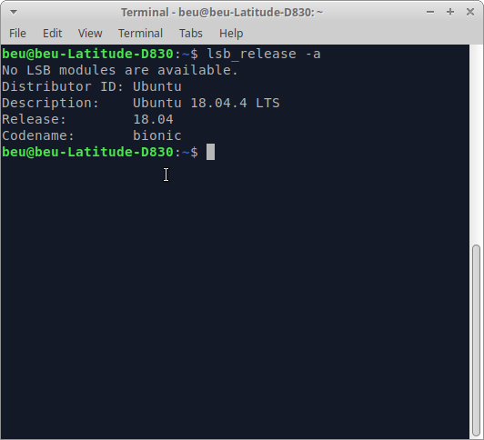
Since I am using Ubuntu Linux 18.04, I chose Mono to run my ASP.NET C# Code. Why because, Mono is an open implementation of Microsoft's .NET framework and it also includes compilers for C#.NET and VB.NET. Moreover, it uses the same development libraries on Linux that exist on Windows.
STEPS TO INSTALL MONO
Step 1: Installing neccesary package using the following commands.
sudo apt update
sudo apt install gnupg ca-certificates
Step 2: Next we need to access the keyserver. And this can be done using apt-key command.
sudo apt-key adv --keyserver hkp://keyserver.ubuntu.com:80 --recv-keys 3FA7E0328081BFF6A14DA29AA6A19B38D3D831EF
Step 3: Adding the Mono package repository. This can be done using the following command.
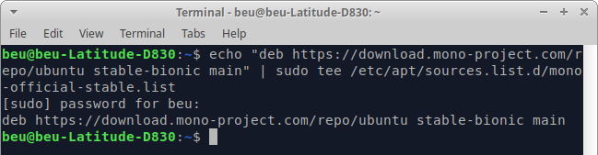
echo "deb https://download.mono-project.com/repo/ubuntu stable-focal main" | sudo tee /etc/apt/sources.list.d/mono-official-stable.list

Step 3 produces the output deb https://download.mono-project.com/repo/ubuntu stable-bionic main.
So I need create a file in the folder /etc/apt/sources.list.d named mono-official-stable.list and copy-paste the above line of deb into it.
This actually refers that we have a Debian archive which is based on "https://download.mono-project.com/repo/ubuntu" and the suite is "stable" and the components are "bionic" and "main".
Step 4: Once the apt repository is enabled we need to update the packages list and install Mono. For this the following command can be used.
sudo apt update
sudo apt install mono-devel
By doing all these, the package mono-devel is installed to the compile code and also the package mono-xsp4 for running ASP.NET applications has installed along with some other packages like mono-complete, mono-dbg and ca-certificates-mono.
Step 5: Mono packages were installed, we can verify it by giving mono --version command.
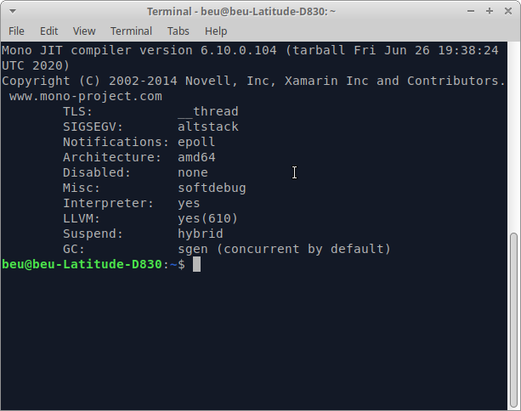

- Write a simple ASP.NET program to display the following Web Controls:
a) A button with text “HI”. The button control must be in the center of the form.
b) A label with a text hello The form name must be Web Controls

<%@ Page Language="C#" %>

<!DOCTYPE html>

<script runat="server">
protected void Button_Click(object sender, System.EventArgs e)
{
Label1.Text = "Hello";
}
</script>

<style>
div.center {
height: 10em;
margin: 0;
position: absolute;
top: 50%;
left: 50%;
margin-right: -50%;
transform: translate(-50%, -50%) }
</style>

<html xmlns="http://www.w3.org/1999/xhtml">
<head runat="server">
</head>
<body>
<form id="form1" runat="server">
<div class=center>
<asp:Label ID="Label1" runat="server"/>

<asp:Button ID="Button1" runat="server" Text="HI" OnClick="Button_Click"/>
</div>
</form>
</body>
</html>

In this code, I have created a ‘hi button’ and a ‘label control’. This hi button has onclick event and I also provided a click event handler. So when we click the hi button, the click event raise and after that the label control displays ‘hello’.

OUTPUT:
In order to run ASP.NET code, we need to start xsp server within the directory of where we saved the program file. Here I saved my file ‘WebControl.aspx’ inside the folder ‘asp’ and it serves the resquest on the port 9000.
